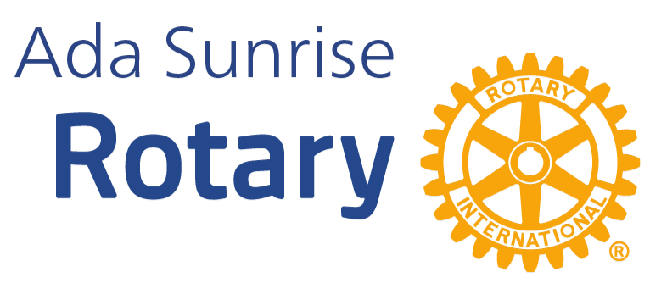"Service Above Self" | We Invite You to Host a Vocational Meeting
Who We Are  Ada Sunrise Rotary Club is a community of professionals, entrepreneurs, educators, and neighbors dedicated to one simple idea: Service Above Self. We are a chapter of Rotary International, one of the world's largest volunteer service organizations, with 1.4 million members across 200+ countries.  Our work touches hundreds of local families each year through initiatives like:  - Back to School Basics, school supplies for 1,000+ Pontotoc County students annually  - Fireball Classic Memorial Race, July 4th fundraiser at Wintersmith Park  - RYLA youth leadership camp sponsorships  - ECU international student scholarships & Rotaract club support  - Disaster relief, veteran recognition, community cleanup, and more |  | What Is a Vocational Meeting?  Once a month, on Fridays with a fifth week, we trade our usual meeting hall for something more meaningful: your workplace.  A Vocational Meeting (or "Vocational Awareness" visit) is one of Rotary's oldest and most valued traditions. Rather than just talking about the professions represented in our club, we go see them firsthand. We visit a member's or community business, learn what they do, why it matters, and how it connects to Ada.  The visit typically runs about 45 minutes, starting at 7:00 a.m., following our normal meeting format with the added highlight of a hosted tour or presentation by you. We bring roughly 15–25 members and guests.

What to Expect as a Host  - 6:45 a.m., Members begin to arrive  - 7:00 a.m., Meeting called to order at your location  - Pledge of Allegiance, Invocation  - Announcements & club news  - "Friday Is Our Favorite Day" song  - Your time: 15–25 min overview of your business or org, tour or demo, Q&A  - Four-Way Test  Bonus: If you have coffee & breakfast on hand, we love it, but we're happy to bring our own food and drinks if that works better for you! | Why Host? What’s in It for You?  - Showcase your business to 15–25 engaged community leaders  - Build authentic relationships with local professionals  - Gain visibility with Rotarians who refer, recommend, and support  - Opportunity to share your story with people who care about Ada  - We promote host businesses on social media before and after the visit  - No cost, no commitment, just a warm welcome  - Hosting is a genuine honor and a great conversation starter

Ready to Host? We'd Love to Visit!

Logistics At A Glance
- Next Opportunity:
  - Friday, May 29, 2026 6:45 AM to 7:45AM, we are actively seeking a host!
  - Friday, July 31, 2026 6:45 AM to 7:45AM, we are actively seeking a host!
  - Friday, October 30, 2026 6:45 AM to 7:45AM, we are actively seeking a host!
  - Friday, January 29, 2027 6:45 AM to 7:45AM, we are actively seeking a host!
- Group Size: Approximately 15–25 members and guests
- What We Need From You: A space for the group, and 15–25 minutes of your story
- What We Bring: Our enthusiasm, a meeting agenda, and gratitude
- Publicity: We'll tag and promote your location on our Facebook page before and after the visit

For more information or to offer to host us, contact our Vocational Services Director:
Ty Butler, tycevisbutler@live.com, 580-399-6584 (text)

Want to learn more about us or check out one of our regular meetings?

Check out our website: https://adasunriserotary.org   | Check out our Facebook: https://www.facebook.com/AdaSunriseRotary  
Meeting Information 📅 When & Where  Every Friday at 6:45 a.m.  Aldridge Ballroom  200 S. Broadway, Ada, OK 74820  Also available via Facebook Live! | 

